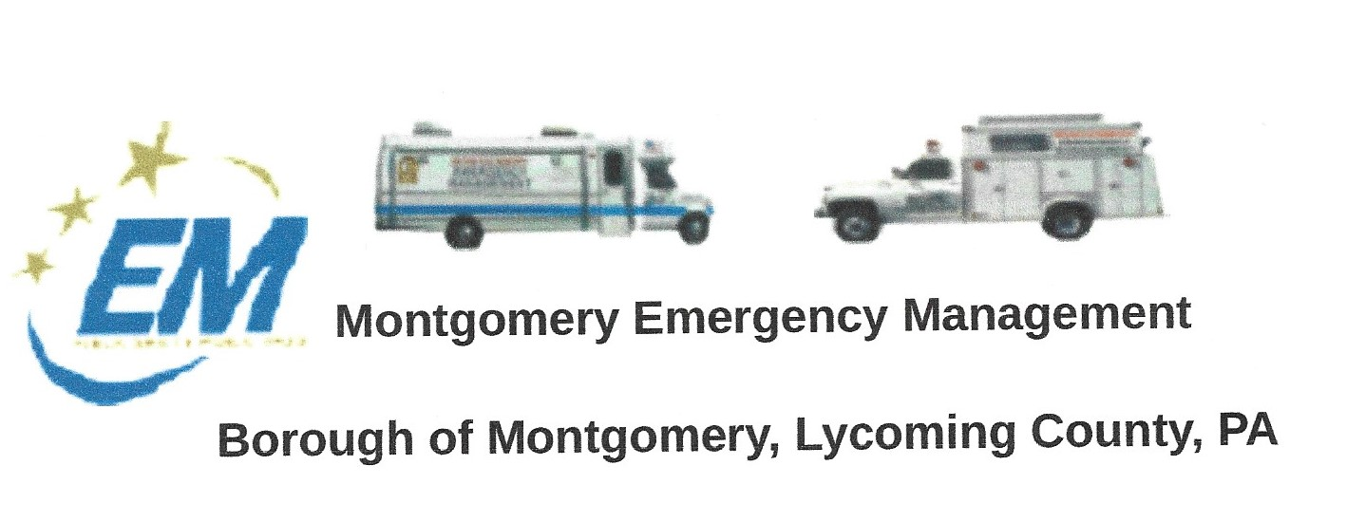
Greg Gruver, EMA Coordinator. 77 E. Houston Avenue, Montgomery, PA 17752
Telephone: 570-547-1212 Cell: 570-419-4866 Email: montema631@gmail.com
Fae Herb, Administrative Assistant. 102 Broad Street, Montgomery, PA 17752
Cell: 570-506-9892. Email: faeherb@aol.com
Meeting Room and Equipment Building: 40 Thomas Avenue, Montgomery, PA 17752
Borough EOC: 570-547-1671 Fire Hall EOC: 570-547-1380
INTERNET WEBSITE: www.montgomeryboroughema.org

NEXT REGULAR MONTHLY MEETING will be held Thursday, January 12th at 7 p.m.
REFRESHEMENTS WILL BE PROVIDED BY DENNIS GRUVER

January 2023 Newsletter
December 2022 ends with excitement for 2023. As COVID restrictions seem to be lifted we enjoyed a successful July Fireworks. Although inflation is on the rise, we kept our prices the same, and profited well.

The EMA finally was able to transfer ownership of the boat donated by CTVFC to the EMA. Lettering and boat registration was put on. Improvements have been made to the EMA building and more are planned for 2023. The EMA “home” is approximately 50 years old. It was donated after the 1972 flood. Past and current members have gone to great endeavors to weatherize and make it last for more years to come.

We also have started fundraising for the purchase of a new truck that will be used for plowing, water readings, hauling the rescue boats and light towers. As well as any other emergency need. Our 1994 Chevy Truck we are hoping to retire this year, but we will keep it maintained until we can purchase a new used vehicle. Thank you to Montgomery Borough, Bower-Decker Legion Post #251, JSSB and Lycoming County Fire Police Association for their generous donations. EMA Coordinator Greg Gruver will be sending out fund raising letters to local business and organizations, and Blaise Alexander dealership is working with the EMA to find a reliable used truck.
The year ends with the EMA providing music and warmth during the “Laying of the Wreaths” ceremony at Fairview Cemetery on Dec. 17th. Toys For Tots boxes were collected and wrapped by the Montgomery Christmas Committee. Food boxes were prepared and on Saturday, December 24th, the Montgomery Fire Company, Clinton Township Fire Company, Washington Township Fire Company and EMA members assisted in loading and delivering the boxes and toys around the Montgomery (school district) area. 181 food boxes and 318 children were blessed from the community donations. 773 toys were collected. Proud of our Community.
What will 2023 bring us….we are hoping new volunteers. We meet the second Tuesday of every month at 7 p.m. at our EMA meeting room located on Thomas Avenue. The meeting room sits behind our EMA garage. Join our water rescue team, help with fundraising and building maintenance. Make it your New Years Resolution to volunteer your time to an organization.

Submitted by Fae Herb; Administrative Assistant

